Launch two ec2-instances and connect it to a application load balancer, where the output traffic from the server must be an load balancer IP address

Launched 2 EC2 instances with different application in each ec2 m/c

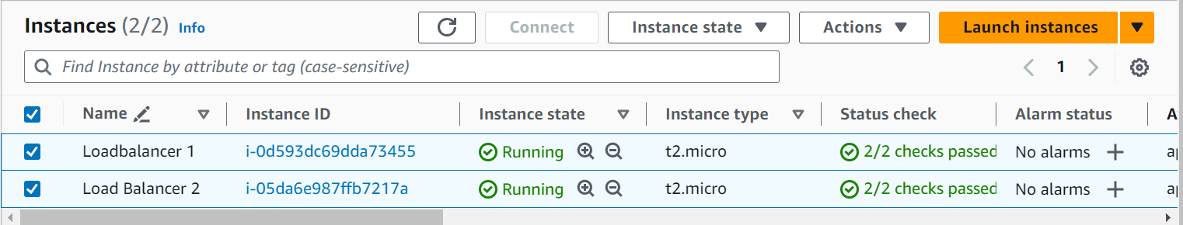

Deploying different application in each ec2 instances

**#!/bin/bash**

**sudo apt update -y**

**sudo apt install nginx -y**

**sudo systemctl enable nginx**

**sudo systemctl start nginx**

**echo "<h1>Hello World from $(hostname -f)</h1>" > /var/www/html/index.html**

**Or**

**#!/bin/bash**

**sudo apt update**

**sudo apt install apache2 wget unzip -y**

**wget https://www.tooplate.com/zip-templates/2132_clean_work.zip**

**unzip 2132_clean_work.zip**

**sudo cp -r 2132_clean_work/* /var/www/html/**

**sudo systemctl restart apache2**

Created an Security group for load Balancer

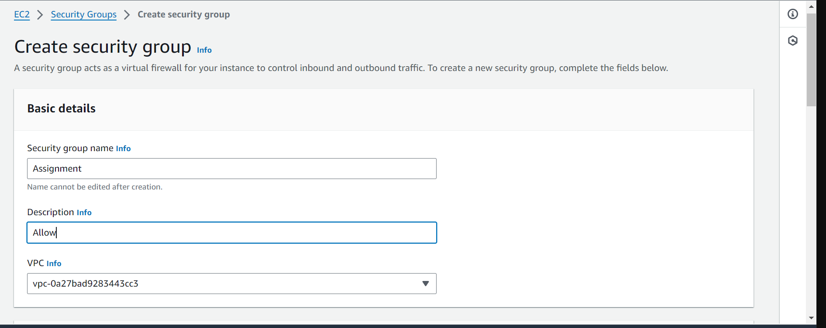

Created an Application Load Balancer

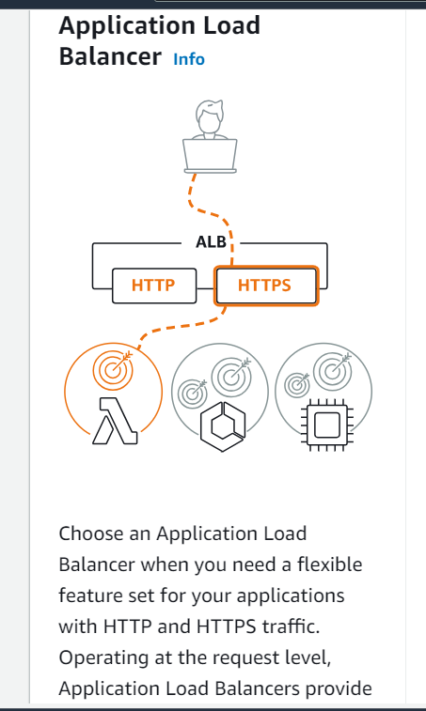

Load Balancer Cration

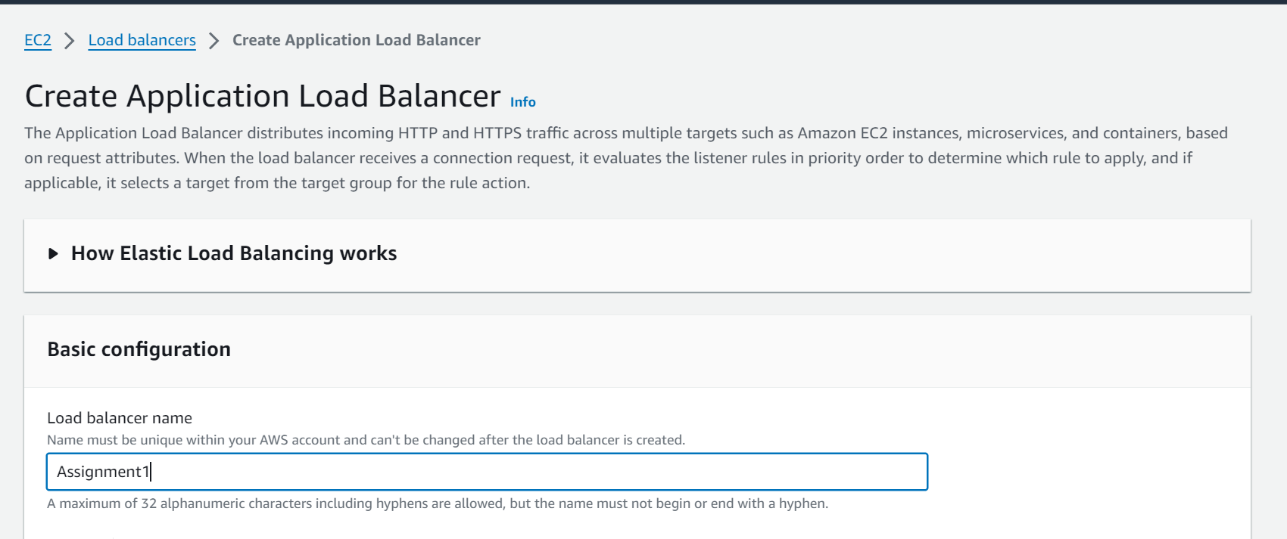

Attaching the Security Group to Load Balancer

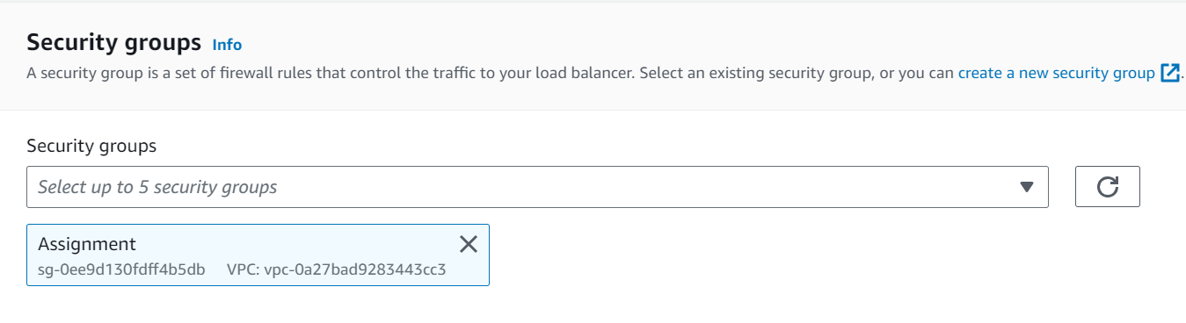

Creating Target group

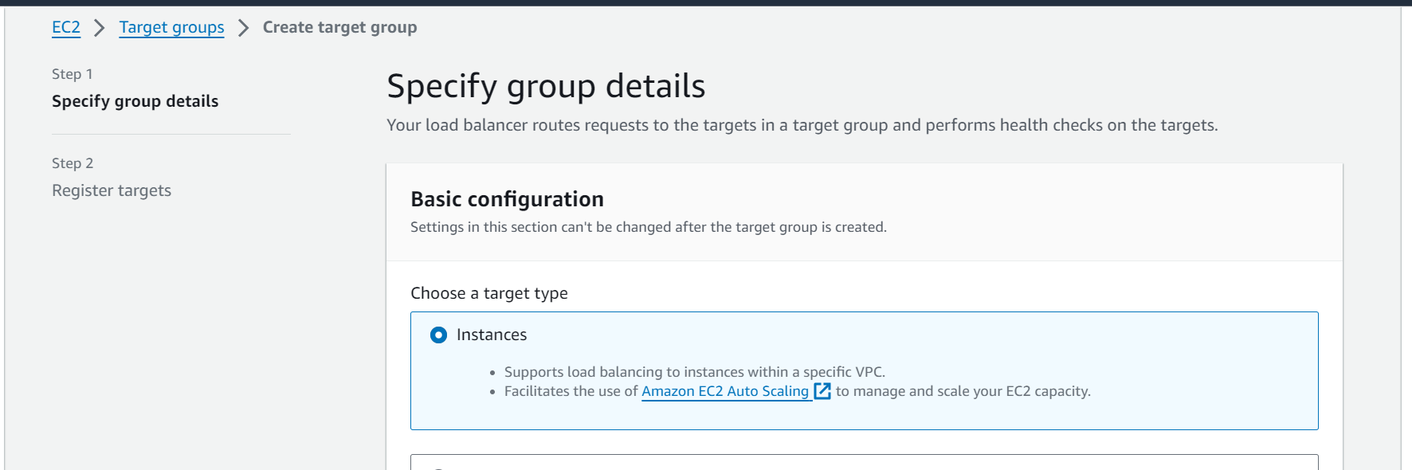

Attaching the Instances to the Target group

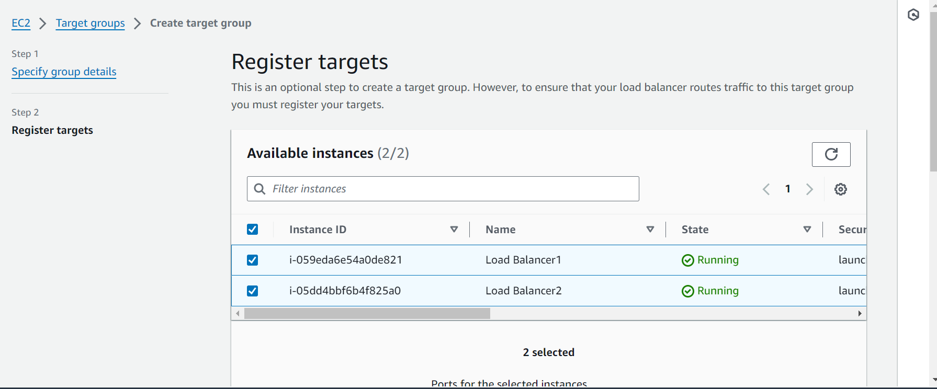

Summary of my Load Balancer

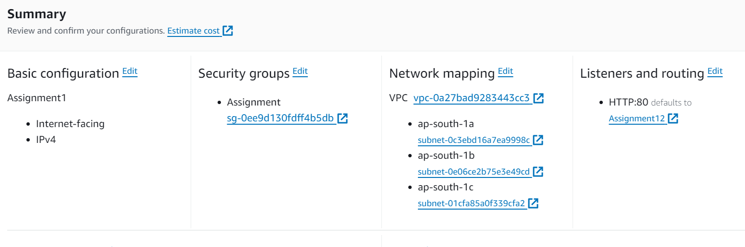

Load balancer is created and active

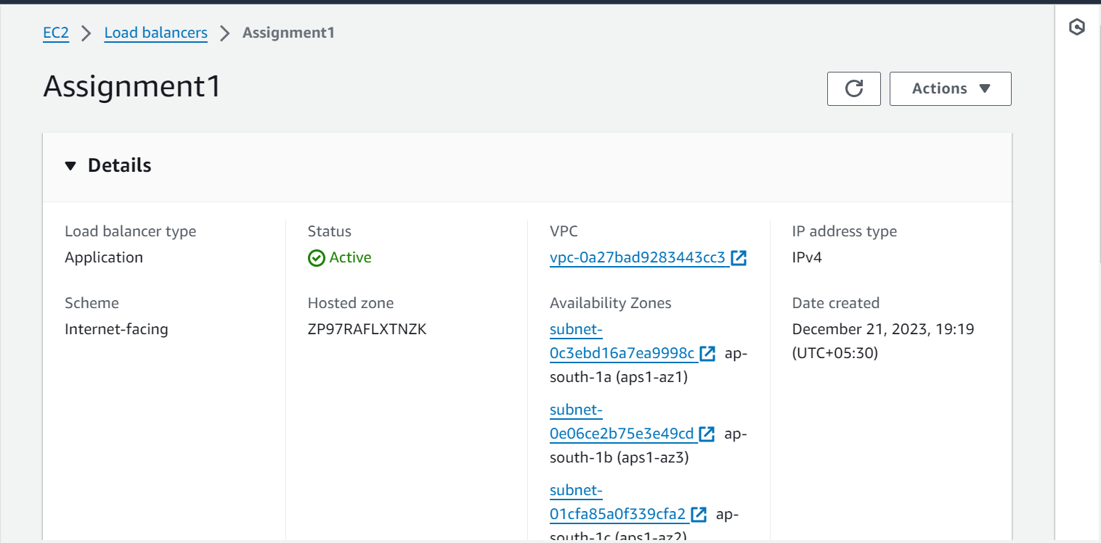

Output:

When we hit the DNS of our Load balancer in the web it will launch our application



When we refresh the web it will route the traffic to another Ec2 m/c

